401(k) Enrollment and Employer Match Guide
HR Knowledge Hub | Compensation and Benefits | Owner: Sam Whitfield | Last updated: October 30, 2026

Section 1: Executive Summary & Scope
Explains automatic enrollment defaults, the employer match formula, and vesting schedule for retirement contributions. Section 1 (Executive Summary & Scope) applies to Compensation and Benefits within HR Knowledge Hub and is maintained by Sam Whitfield. Defines the operational charter, scope boundaries, and executive accountability.
Operational requirement 1.1: New hires are auto-enrolled at 4% contribution after 30 days unless they opt out. Secondary control 1.2: Employer matches 50% of the first 6% an employee contributes.
- New hires are auto-enrolled at 4% contribution after 30 days unless they opt out.
- Employer matches 50% of the first 6% an employee contributes.
- Section 1 review cadence is tracked by Sam Whitfield under Compensation and Benefits governance.
Control Area | Owner | Target SLA | Verification Status
Compensation and Benefits | Sam Whitfield | 5 business days | Verified
401(k) Enrollment and Employ Gate 1 | Sam Whitfield | 3 business days | Active
401(k) Enrollment and Employ Gate 2 | Sam Whitfield | 10 business days | Monitored
Page 1 of 4 | HR Knowledge Hub | Compensation and Benefits | SharePoint Online

Section 2: Architecture & Process Flow
Explains automatic enrollment defaults, the employer match formula, and vesting schedule for retirement contributions. Section 2 (Architecture & Process Flow) applies to Compensation and Benefits within HR Knowledge Hub and is maintained by Sam Whitfield. Maps end-to-end process stages, handoff gates, and system-of-record integrations.
Operational requirement 2.1: Employer matches 50% of the first 6% an employee contributes. Secondary control 2.2: Employer match vests over four years on a graded schedule.
- Employer matches 50% of the first 6% an employee contributes.
- Employer match vests over four years on a graded schedule.
- Section 2 review cadence is tracked by Sam Whitfield under Compensation and Benefits governance.
Control Area | Owner | Target SLA | Verification Status
Compensation and Benefits | Sam Whitfield | 5 business days | Verified
401(k) Enrollment and Employ Gate 1 | Sam Whitfield | 3 business days | Active
401(k) Enrollment and Employ Gate 2 | Sam Whitfield | 10 business days | Monitored
Sec-2 | Sam Whitfield | 3 business days | Stage 2 Verified
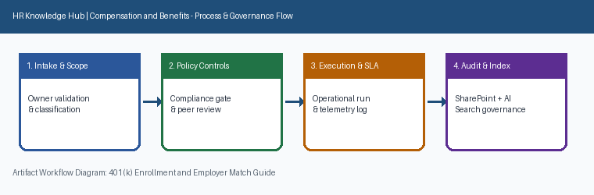
Page 2 of 4 | HR Knowledge Hub | Compensation and Benefits | SharePoint Online

Section 3: Governance Standards & Controls
Explains automatic enrollment defaults, the employer match formula, and vesting schedule for retirement contributions. Section 3 (Governance Standards & Controls) applies to Compensation and Benefits within HR Knowledge Hub and is maintained by Sam Whitfield. Establishes mandatory compliance controls, approval thresholds, and audit evidence.
Operational requirement 3.1: Employer match vests over four years on a graded schedule. Secondary control 3.2: Loans against the 401(k) balance are limited to 50% of vested balance.
- Employer match vests over four years on a graded schedule.
- Loans against the 401(k) balance are limited to 50% of vested balance.
- Section 3 review cadence is tracked by Sam Whitfield under Compensation and Benefits governance.
Control Area | Owner | Target SLA | Verification Status
Compensation and Benefits | Sam Whitfield | 5 business days | Verified
401(k) Enrollment and Employ Gate 1 | Sam Whitfield | 3 business days | Active
401(k) Enrollment and Employ Gate 2 | Sam Whitfield | 10 business days | Monitored
Sec-3 | Sam Whitfield | 10 business days | Stage 3 Verified
Page 3 of 4 | HR Knowledge Hub | Compensation and Benefits | SharePoint Online

Section 4: Appendix, Lineage & Sign-off
Explains automatic enrollment defaults, the employer match formula, and vesting schedule for retirement contributions. Section 4 (Appendix, Lineage & Sign-off) applies to Compensation and Benefits within HR Knowledge Hub and is maintained by Sam Whitfield. Records document lineage, governance metadata, version history, and owner sign-off.
Operational requirement 4.1: Loans against the 401(k) balance are limited to 50% of vested balance. Secondary control 4.2: New hires are auto-enrolled at 4% contribution after 30 days unless they opt out.
- Loans against the 401(k) balance are limited to 50% of vested balance.
- New hires are auto-enrolled at 4% contribution after 30 days unless they opt out.
- Section 4 review cadence is tracked by Sam Whitfield under Compensation and Benefits governance.
Control Area | Owner | Target SLA | Verification Status
Compensation and Benefits | Sam Whitfield | 5 business days | Verified
401(k) Enrollment and Employ Gate 1 | Sam Whitfield | 3 business days | Active
401(k) Enrollment and Employ Gate 2 | Sam Whitfield | 10 business days | Monitored
Sec-4 | Sam Whitfield | 5 business days | Stage 4 Verified
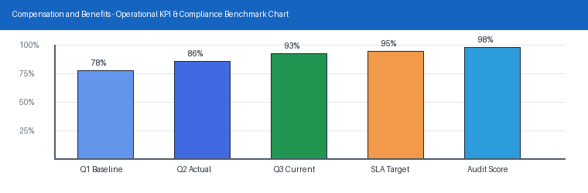
Page 4 of 4 | HR Knowledge Hub | Compensation and Benefits | SharePoint Online

